**Software Requirements and Design Document**

**For**

**Group 14**

Version 1.0

**Authors**:

Conner F

Ryan R

James H

Davion M

DJ S

# Overview

Gustbuddy will be a functional web application that will deliver a myriad of weather information to the user which can be shared through social media. We are proposing to develop the web app with a variety of APIs and custom algorithms to refine and personalize weather data for users accessing the app.

The system aims to deliver relevant, personalized, location-based weather information to users. Florida specific data related to weather and hurricane forecasts, hurricane data and statistics, and

# Functional Requirements

1. Day/Week/2 Week weather forecast (HIGH)
2. On-this day past weather report breakdown (HIGH)
3. Florida Hurricane Damage Analysis Breakdown (HIGH)
4. Hurricanes in Florida Analysis breakdown (HIGH)
5. API data utilization (HIGH)
6. User login/notifications (MEDIUM)
7. Florida Focus (MEDIUM)
8. Social media sharing implementation (LOW)
9. Hurricane Probability (LOW)

# Non-functional Requirements

1. user’s usernames passwords were secured through Firebase
2. Peer-reviewed code for efficiency
3. Ensured 3-hour weather update refresh while the web app is open

# Use Case Diagram

Actors: User, Administrators

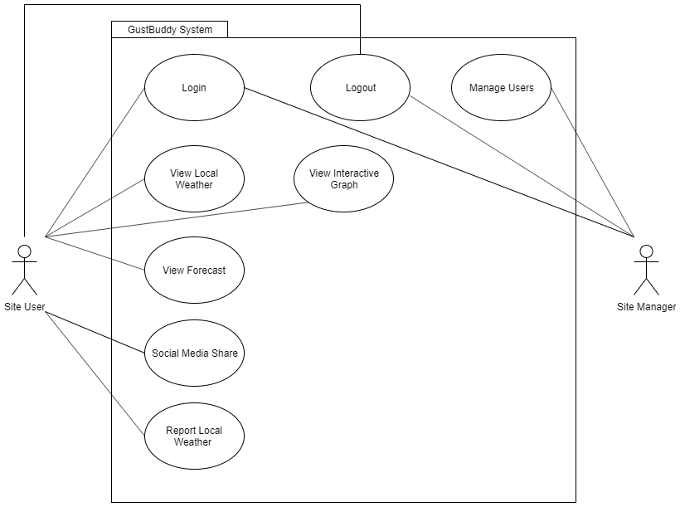

The Gustbuddy system is accessed by both site users and site managers. The site user is able to login, access the Forecast, Weather, and Statistics page. They are also able to report local weather (which is stored in Firebase), share Gustbuddy on Facebook, Twitter, and LinkedIn, as well as Sign out. The site manager is able to login and logout with the admin account, and can manage user login data (without password access) and view reported local weather.

# Class Diagram and/or Sequence Diagrams

Class Diagram:

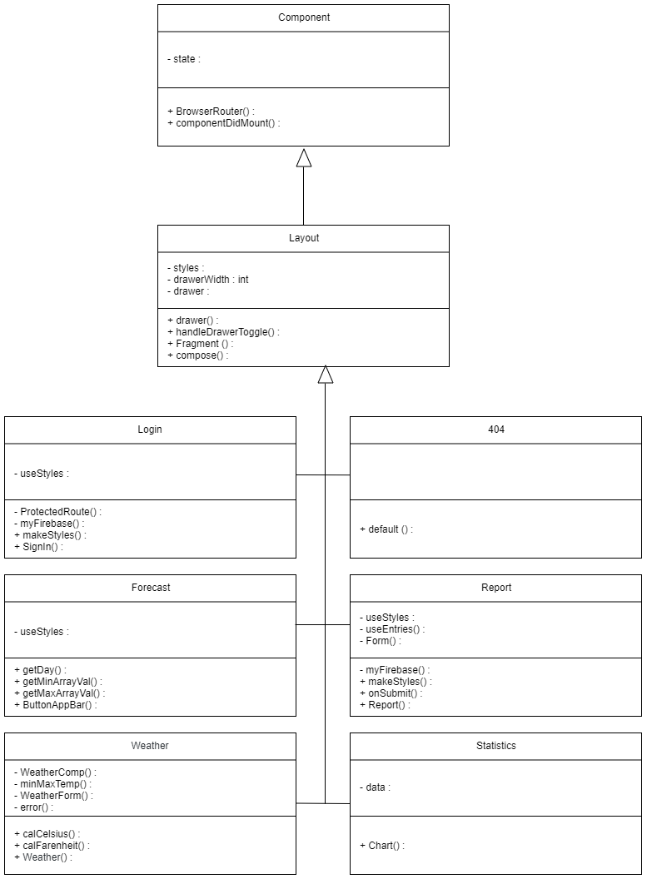

Sequence Diagrams:

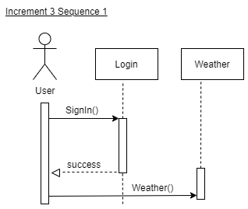

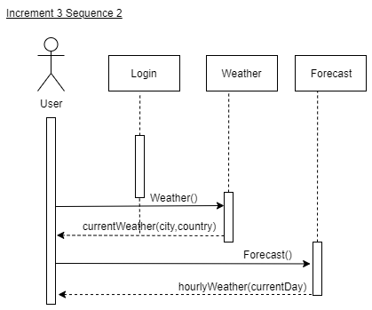

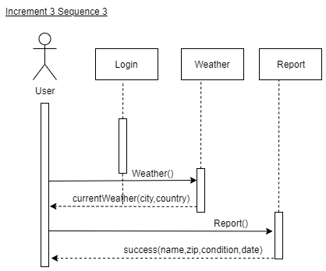

# Operating Environment

The software currently operates as a locally hosted web application. The goal is for the web application to be published and be accessed from any remote host with an internet connection.

Hardware platform: Any

Operating system: Any

# Assumptions and Dependencies

Assumptions

* N/A

Dependencies

* Firebase
* Recharts
* React
* MaterialUI